
Town of Wellfleet - Board of Selectmen

Wellfleet Public Library

January 22, 2008

Regular Meeting - Minutes

The meeting was called to order at 7:00 p.m. by Vice Chair Michael May. Selectmen present included Ira Wood Jerry Houk and Dale Donovan. Chairwoman Jacqui Beebe was absent. Town Administrator Paul Sieloff also attended.

- Public Hearing
  - Amend Shellfish Regulations
(Postponed till February 12, 2008, Requested by Shellfish Advisory Committee)

- New Seasonal Wine & Malt On Premise License
Marjon Corp., John O’Brien mgr., d.b.a. Monkey See Monkey Do, 2207 State Highway.
Represented by Atty. Nancy Coreia and John O’Brien.
MOTION 08 - 0008: To move that the Board of Selectmen vote to approve the new Seasonal Wine & Malt License, conditioned of passing the Health Agent’s Inspection.
Motion by: Dale Donovan Seconded by: Ira Wood. Yea 4 Nay 0

- Open Session & Announcements
    - Monday January 28th at 7pm – Wellfleet Forum discussion with new Town Administrator
    - Ira Wood attended the Annual Martin Luther King Meditation this past weekend, and would like to thank Harriet Korim.
    - Jerry Houk attended the Wellfleet vs. Chatham basketball game.
    - Dale Donovan would like to thank DPW for repairing the light behind the library.

- New Business
- Appointments
- Kenneth Roscoe – Council on Aging
- Ellen Ishkanian – Council on Aging
MOTION 08-0009: To move that the Board of Selectmen vote to approve the appointments.
Motion by: Ira Wood Seconded by: Jerry Houk. Yea 4 Nay 0

  - Business License Renewals
    - Used Car Dealership – Vintage Auto Center
    - Automatic Amusement – Southfleet Motor Inn
    - Common Victualer – Mainstay Motor Inn & Wellfleet Motel & Lodge
MOTION 08-0010: To move that the Board of Selectmen vote to approve the business license renewals.
Motion by: Dale Donovan Seconded by: Ira Wood. Yea 4 Nay 0

  - Approval of IRS 2008 Standard Mileage Rate
MOTION 08-0011: To move that the Board of Selectmen vote to approve the IRS 2008 Standard Mileage Rate.
Motion by: Ira Wood Seconded by: Dale Donovan. Yea 4 Nay 0
  - Wellfleet Fire Station – Construction Change Orders
Represented by Hugh Guilderson and Fire Chief Dan Silverman. Mr. Guilderson is requesting the board’s approval of giving authority to the Fire Chief and Bill Reich to approve change orders up to $5,000. This would allow production to continue while avoiding extension of contract time. The board will be informed of the $5,000 change orders. Jerry Houk would like either a cumulative point of change orders that can be approved without the Board of Selectmen, or have the addition of the Town Administrator’s signature on the change order. The Board of Selectmen would like to discuss this more, and will give feedback to the Town Administrator who will report to the Building Needs & Assessment Committee.

  - Environmental Partners Group Project Updates
Represented by Bob, Kevin McQue & Paul Millett.
- Paul gave the board an update about the Water System extension. They are planning on building a well at Boy Scout Camp in order to complete phases 3-5. They plan on getting it out to bid by this spring. Jerry Houk is concerned with notifying the public about user fees. Mark Berry spoke about having actual $ figures ready by April Town Meeting possibly. Helen Miranda Wilson spoke about how most costs will come to the public after the system is up and running; personnel, maintenance, etc.
- Kevin McQue gave the board an update on Uncle Tim’s Bridge. Construction is planned to begin after Labor Day, due to funding options. Robert B. Our, the lowest bid, has agreed to extend their bid. Rex Peterson informed the board that he will go before the CPC once more applying for more monies to be granted, or place an article on Town Meeting for borrowing. Helen Miranda Wilson suggested possible grant money available. Ira Wood would like Rex Peterson to contact the Cape Cod Commission to find possible grant money.

- Old Business
  - Wastewater Planning Committee
Represented by Health Agent Hillary Greenberg and Board of Health Chair Richard Willecke. Hillary Greenberg informed the board that the Board of Health voted to notify the Board of Selectmen that they are willing to take on Wastewater Issues. Dale Donovan doesn’t believe that Board of Health should tackle this in addition to their own duties since it would be more complex than just health issues. He feels a broader committee would be more beneficial to the town. Richard Willecke is concerned with volunteer services in filing voids on committees. He feels that it would be more efficient to the current volunteers to stay a little later at already scheduled meetings and addressing wastewater issues, rather than go to an additional meeting that might not fit into 7 members schedules. Both Jerry Houk and Michael May agree with Richard Willecke. Mark Berry spoke in favor of having the Board of Health adding the Wastewater workload.
MOTION 08-0012: To move that the Board of Selectmen vote to rescind the 2 appointments of community members to the Wastewater Planning Committee.
Motion by: Jerry Houk. Seconded by: Michael May. Yea 3 Nay 1

Dale Donovan suggested allowing the Board of Health add Wastewater on their work load but also have two community members.

MOTION 08-0013: To move that the Board of Selectmen vote to approve two additional community members with the Board of Health to address Wastewater Issues.
Motion by: Jerry Houk. Seconded by: Dale Donovan Yea 4 Nay 0

- Correspondence
Mr. Wood reviewed the correspondence report dated 12/12 – 1/07.
    - Ira Wood mentioned a letter about watering systems, and would like a copy of it given to the Board of Health

- Minutes
- January 8, 2008
- January 15, 2008
MOTION 08-0014: To move that the Board of Selectmen vote to approve the January 8 & 15, 2008 minutes as written.
Motion by: Ira Wood. Seconded by: Dale Donovan. Yea 4 Nay 0

  - Future Meetings/Agendas

MOTION 08-0015: To move that the Board of Selectmen adjourn the regular meeting.
Motion by: Ira Wood. Seconded by: Dale Donovan. Yea 4 Nay 0

The regular meeting adjourned at 8:30 p.m.
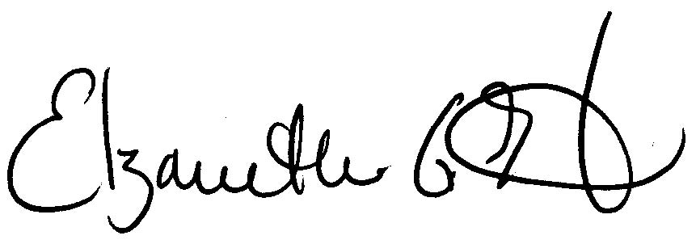
Respectfully submitted,

Elizabeth G. Hartsgrove
Executive Assistant

______
Jacqueline Beebe, Chair Michael May Ira Wood

Dale Donovan Jerry Houk

